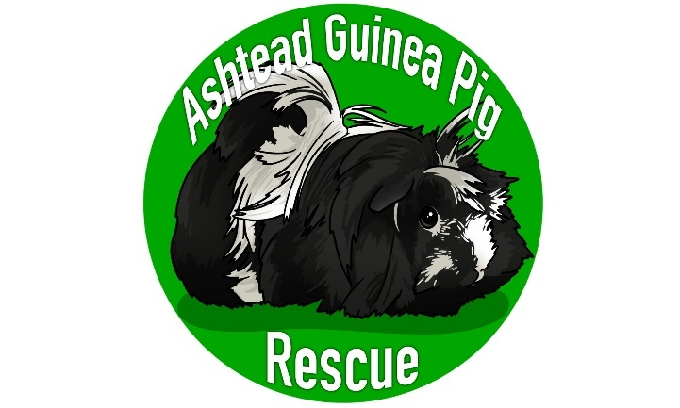
APPLICATION TO SURRENDER GUINEA PIG(S)
Once complete please send to
ctear@ashteadpetboarding.co.uk
Minimum Surrender Donation of £20 each
APPLICANT DETAILS

Surname |  | First Name |  | date
Address
Contact Number |  | E-mail
Ashtead Guinea Pig Rescue is collecting your details because you are considering surrendering a pet to us. We need your data so that we can match your pet with the right new owner. We take your privacy very seriously and promise to keep your information safe. We'll never give away or sell your details to other organisations to use for their own purposes either.

SURRENDER GUINEA-PIG(S) DETAILS

Please provide as much information as possible including photos of the guinea pig(s).
Name of guinea pig(s) |  |  | What sex are they?
What breed are they?  Please provide up-to-date photos by email. |  |  | How old are they?
Are there any health issues to pass on?  (Please continue via email if needed) |  |  | Are they Neutered?
Details of current setup – are the guineas living indoors, sheltered outdoors (e.g. shed, garage) or in an outdoor hutch? Do they have access to grass time?

Any other information e.g. temperament, are they good to handle, are they used to children, do you want them to stay
together?

Please describe in detail why you are surrendering your pet: -
By signing this form, I state that I am the owner of the animal(s) who is/are the subject of this Animal Surrender Form, hereinafter referred to as “the animal.” To my knowledge, no other person has any right to this animal. I hereby surrender all rights to the animal. I understand that once I relinquish the animal, the animal will not be available to be returned. I have read and understand this Animal Surrender Form.

I confirm I am over 18 years of age and all the information I have provided is correct to the best of my knowledge.

Signed |  | Print Name |  |  | Date
AGPR STAFF TO COMPLETE

Name(s) of Guinea-Pig(s) |  | Age(s) |  | Date Surrendered
Description |  |  |  | Date of neutering
Evidence of Address Seen
Evidence of Accommodation Seen
Additional Comments/Notes

