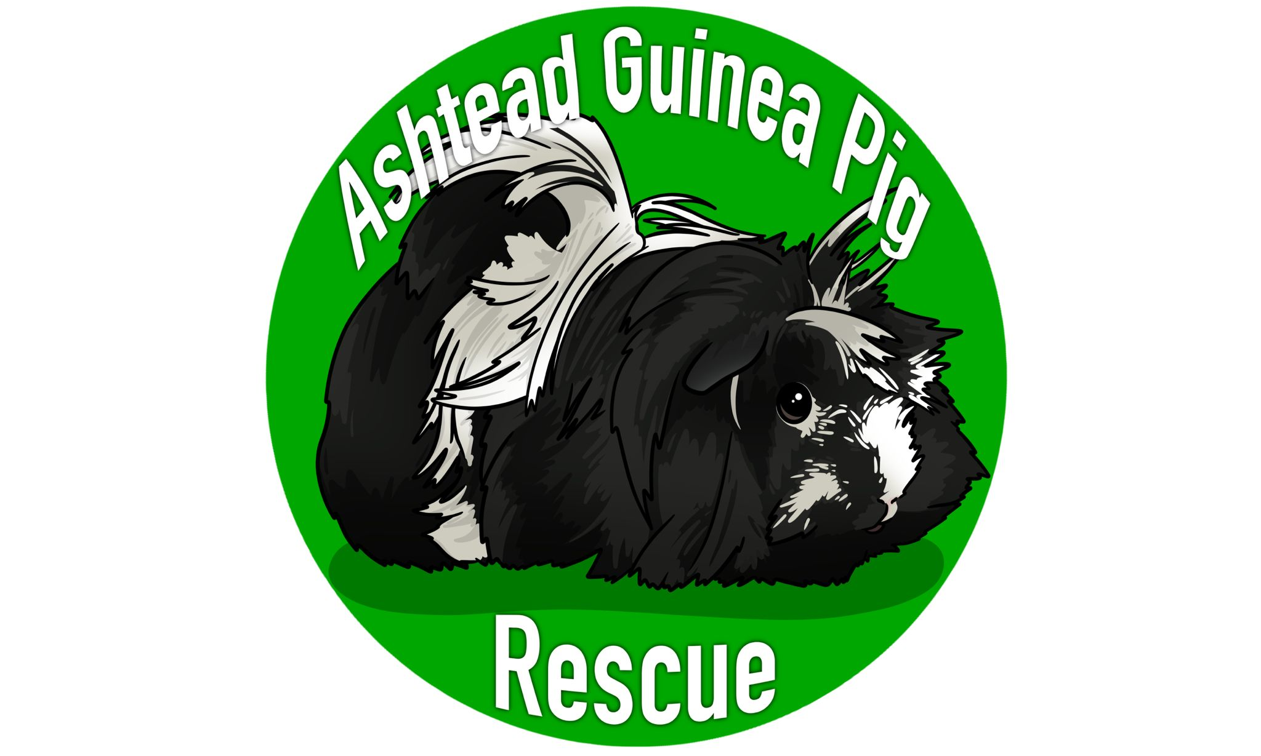
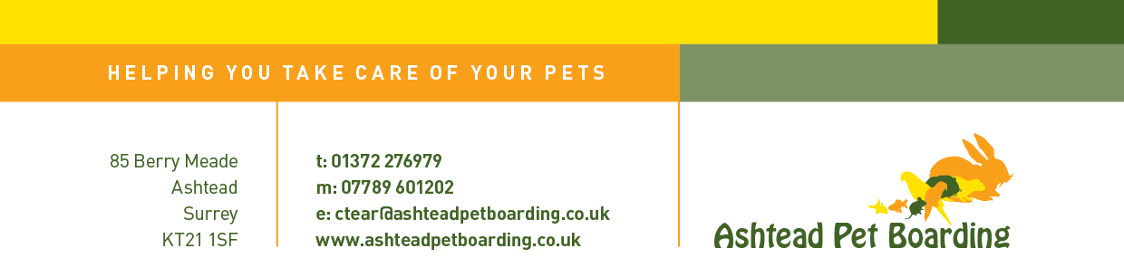

VOLUNTEER APPLICATION FORM

TO BE COMPLETED BY THE APPLICANT

Please remember that an interview is a two way process – think of it as a conversation. All information will remain confidential

First Name: __________________ Surname: ______________________

Date of Birth: _________________________ (if you’re under 21!)

Age at start of volunteering period: ________ (If under 18 years please complete the parental consent section below)

Home Address: ________________________________________________________________

_________________________________________________________

Telephone No: ____________________________

Mobile Tel No: ____________________________
Email Address: _____________________________________________

Are you participating in the Duke of Edinburgh’s Award Scheme?

____________

If Yes: Which level? __________ Which section?______________

How many months? _____________

Days available: (Please indicate)

Monday Tuesday Wednesday Thursday Friday Saturday Sunday

We would normally expect you to commit to one hour per week for DofE but at busy times you may like to stay for more.

Why would you like to do voluntary work at Ashtead Pet Boarding & Guinea Pig Rescue?

_________________________________________________________
_________________________________________________________
_________________________________________________________

When would you be free to start? (This is a rough idea, not a commitment):

_________________________________________________________

Do you have a disability or health issue that we need to be aware of in order for you to get the most out of your volunteering work?

_________________________________________________________

_________________________________________________________

Please let us know if there are any medications we need to be aware of (eg inhaler):

_________________________________________________________
Previous work experience (Paid or Unpaid):

_________________________________________________________

_________________________________________________________

Any other information relevant to the role:

_________________________________________________________

_________________________________________________________

How did you hear about Ashtead Pet Boarding & Guinea Pig Rescue?

_________________________________________________________

Please supply the names and addresses of two referees, who know you well, e.g. previous employer, neighbour, head teacher, previous volunteering project, etc. Please note that these cannot be a relative.

Name: __________________ Name:______________________

Relationship to Referee: Relationship to Referee:

________________________ ___________________________

Position: ________________ Position: ____________________

Address: ________________ Address: ____________________

________________________ ___________________________

Tel No:__________________ Tel No: _________________

Signed – Volunteer: ____________________ Date: __________

PARENTAL/GUARDIAN CONSENT

I ______________________ give my permission for

____________________________________________________

to undertake the duties of a volunteer helper at Ashtead Pet Boarding & Guinea Pig Rescue.

Signed: _______________________ Date:__________________

* Important information:- Ashtead Pet Boarding & Guinea Pig Rescue is a busy work environment with both indoor and outdoor facilities. All volunteers should wear appropriate clothing and protective footwear (ie not flip flops) that you do not mind getting dirty. Please respect our property and our neighbours. We will do everything to offer you a positive volunteering experience.

